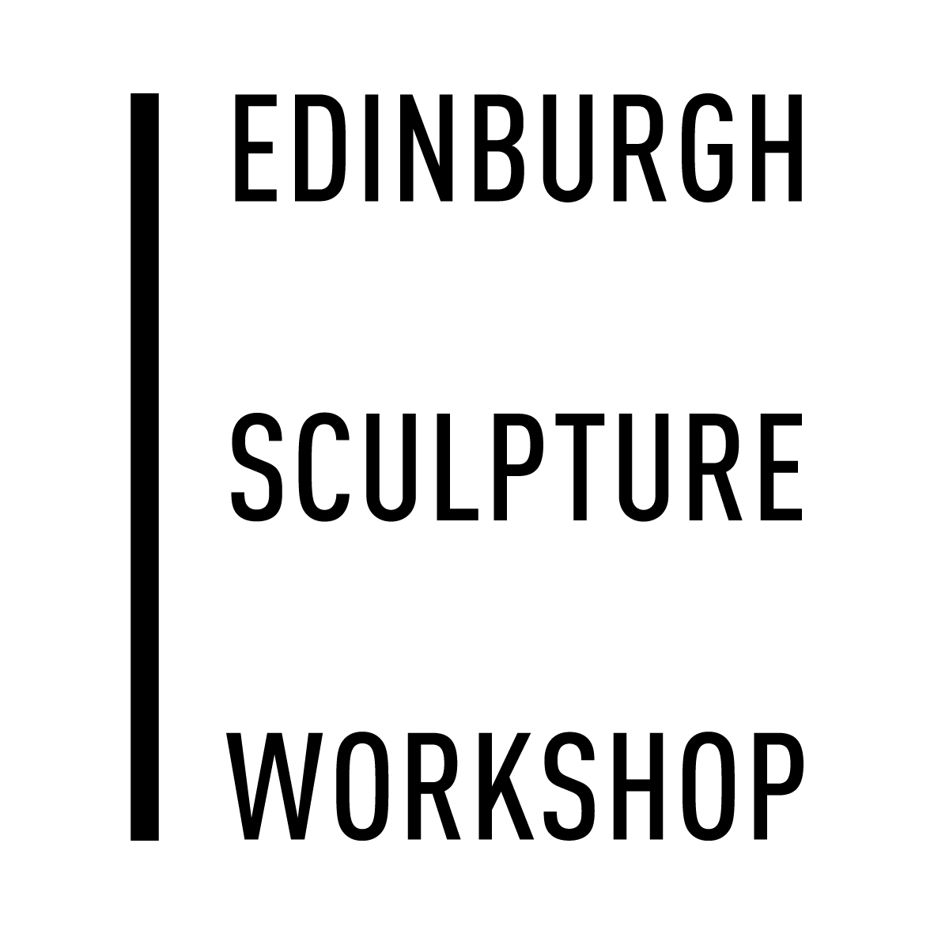 | Micro Residencies 2018-19 Information Sheet  Deadline: 9th June 2018 @ Midnight
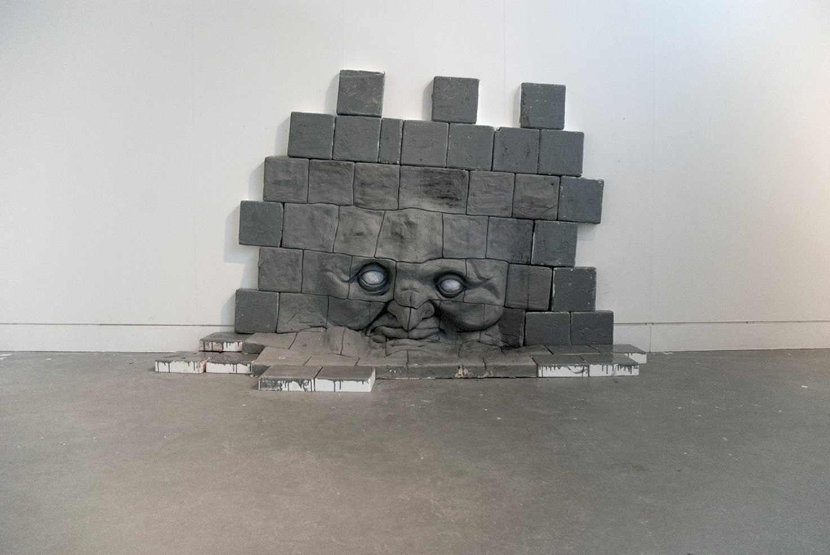
Untitled, Jack Cheetham, Micro Resident 2017/18

Applications are invited from artists working in any medium for the 2018/19 Micro Residency Programme at Edinburgh Sculpture Workshop.

The Micro Residency programme is a research and development opportunity for artists at any stage of their career. Designed to foster experimentation and innovation, these residencies allow the participants to engage in an intensive six week period of production, testing and investigation while living in the onsite apartments.

The programme’s aim is to enable artists to develop ideas, learn new skills and produce work supported by the staff and the resources of ESW.

As well as having 24hr access to their studio residents can make use of the workshop facilities, spaces and research resources available. There are two apartments onsite, one of which is suitable for families

The residents will also be part of a vibrant and welcoming studio and artistic community opening up the networking and peer review opportunities.

Edinburgh Sculpture Workshop is based in Newhaven close the cultural hub of Leith and with easy access to the centre of Edinburgh. This places it within a network of galleries, museums, and technical facilities. The residency also provides opportunities for networking between residents and the broader cultural life of Scotland. There is no exhibition outcome expected from the residency.
The building and resources are accessible but if you would like to further information about our support for any specific needs or requirements do get in touch.

Structure

There are four Micro Residencies throughout the year with each lasting six weeks, artists will receive:
- £1,000 stipend
- Studio
- Accommodation
- Training and support from the technical team in material processes and equipment
- Support from the programme team
- Access to all workshops / spaces
- 1 year’s Membership of ESW

How to apply:

Please complete the application form, and send with the following:
- A one-page statement of outlining your practice, your interest in the Residency, and how it will benefit your work.
- CVs of all artists involved
- Supporting material - This must be in the form of a pdf containing up to 8 images and no larger than 10mb in size. You can include links to work online and your website within this document. If you want to include moving image/sound work in your application either include links to your work online or send them via dropbox or a similar file sharing utility.

There are three residency time slots. Please indicate at least two preferences.
September – October 2018
January – February 2019
March – April 2019

Receipt of all applications will be acknowledged within 5 days please contact the office if you don’t receive this acknowledgement by then.

If you have any further questions about any aspect of the application please either phone 0131 551 4490 or e-mail dan@edinburghsculpture.org.

Please send applications by e-mail to dan@edinburghsculpture.org
Selection Panels and Timescales

All of Edinburgh Sculpture Workshop’s artistic activities are selected by a panel of arts professionals. The Micro Residency panel is chaired by Dan Brown, Curator of Research at Edinburgh Sculpture Workshop.
The external selectors for this year’s Micro Residency Programme are:

Viviana Checcia - Public Engagement Curator CCA
Alberta Whittle - Artist, Committee Member Transmission

Eligibility

This opportunity is open to artists working in any discipline at any stage of their career. Students in full time education are ineligible to apply.

Feedback
ESW will inform all applicants of the outcome of the process and offer feedback on unsuccessful applications if requested.

Data
The information provided by you will only be used to inform the selection process and will not be retained once selection has been completed, typically three months following the application deadline. Edinburgh Sculpture Workshop will never lease, distribute or sell personal information to third parties unless the owner’s consent has been given or it is required by law. Any personal information held by Edinburgh Sculpture Workshop is stored and processed under the company’s Data Protection Policy, in line with the General Data Protection Regulation effective from 25 May 2018.

